GREENRIVERS
Maintenance Mode

Magento module maintenance mode

Table of Contents
I Requirements 3
II Installation 3
1) Module 3
III Usage 3
1) Config 3
III Dev notes 6
1) Backend access 6
2) Areas 6
3) Commands 6
4) Log files 7

I Requirements
- PHP >= 7.1
- Magento >= 2.3

II Installation

1) Module
php bin/magento module:enable Greenrivers_MaintenanceMode
php bin/magento setup:upgrade
php bin/magento setup:di:compile
php bin/magento setup:static-content:deploy -f

III Usage

1) Config
Stores → Configuration → GREENRIVERS → Maintenance Mode

General → Enabled - module activation

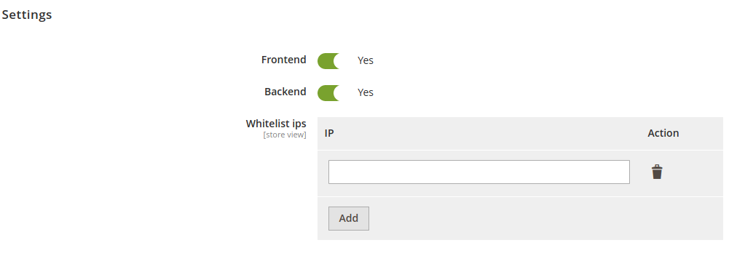

Settings → Frontend – enable maintenance mode in frontend
Settings → Backend – enable maintenance mode in backend (warning: if You toggle this option, then admin dashboard can’t be accessible)
Settings → Whitelist ips – list of addresses which will be excluded from maintenance mode (working on both areas: frontend & backend)
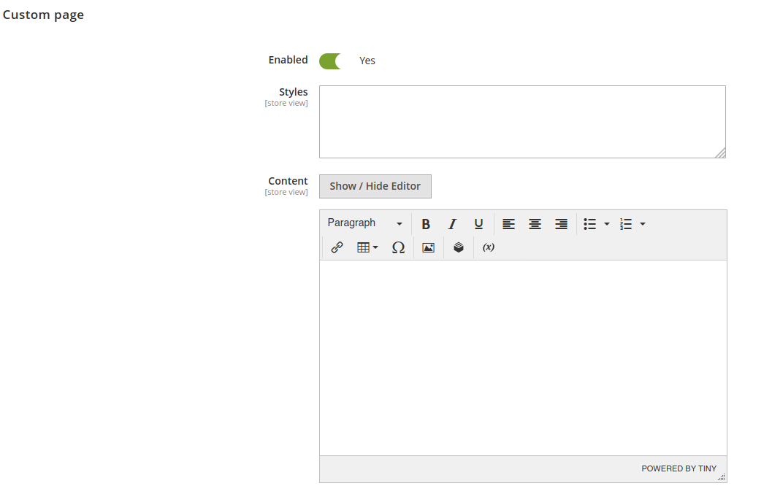
Custom page → Enabled – enable if You want to override default maintenance template
Custom page → Styles – add custom css rules for maintenance page (don’t wrap content in <style> tag)
Custom page → Content – content of Your custom maintenance page

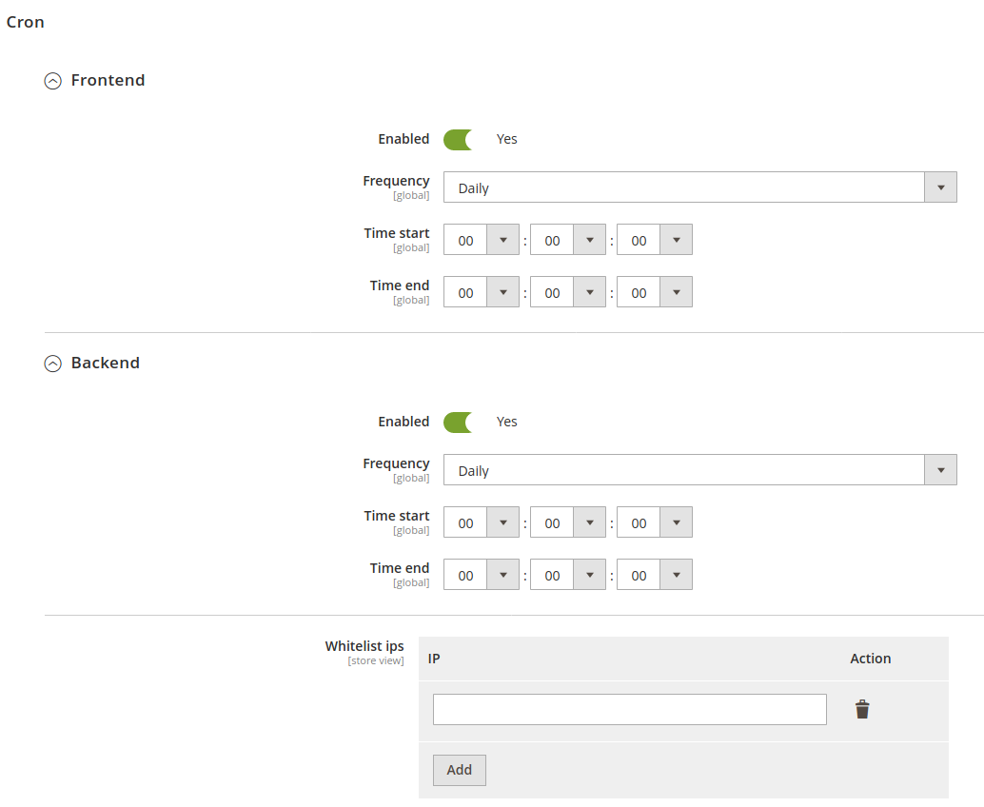
Cron → Frontend → Enabled – enable cronjob for maintenance mode in frontend
Cron → Frontend → Frequency – frontend cron frequency
Cron → Frontend → Time start – enable frontend maintenance time
Cron → Frontend → Time end – disable frontend maintenance time

Cron → Backend → Enabled - enable cronjob for maintenance mode in backend
Cron → Backend → Frequency - backend cron frequency
Cron → Backend → Time start - enable backend maintenance time
Cron → Backend → Time end - disable backend maintenance time

Cron → Whitelist ips - list of addresses which will be excluded from cronjobs maintenance mode (working on both areas: frontend & backend)

You must flush Magento cache after all of those operations.

III Dev notes

1) Backend access
Backend = Adminhtml = Admin dashboard
Keep in mind that after enable maintenance in backend and save config site should showing 503 page (maintenance mode: on).
There are some ways to again access admin:
- commands: maintenance:disable / greenrivers:maintenance:disable
- delete var/maintenance.flag file
- waiting for backend cron maintenance disabled time

2) Areas
Magento2 checking maintenance mode before set up area state.
For this reason to determine areas works like this:
- frontend – current url starts with base url prefix
- backend – current url starts with base url prefix with admin uri

3) Commands
There are 2 commands which works the same as operations in config settings section.
greenrivers:maintenance:enable
It has one argument:
- whitelist-ips – specify excluded addresses for maintenance mode (separated by comma)
It has also two flags:
- frontend – enable maintenance in frontend
- backend – enable maintenance in backend
To enable maintenance mode on both areas run command without flags.

Example:
We want to enable maintenance in frontend excluded localhost.
To achieve this run below command:
greenrivers:maintenance:enable --frontend --whitelist-ips=127.0.0.1

greenrivers:maintenance:disable
It has two flags:
- frontend – disable maintenance in frontend
- backend – disable maintenance in backend
To disable maintenance mode on both areas run command without flags.
Example:
We want to disable maintenance in backend.
To achieve this run below command:
greenrivers:maintenance:disable --backend
You must flush Magento cache after all of those operations.

4) Log files
Errors are logged in var/log/greenrivers/maintenance_mode.log file.

